Etumos Framework

Lead Source Documentation

Introduction
This Lead Source Program is a default operational program designed to capture the first, last and every UTM values for a person and translate those values into a Last/First/Every Lead Source, Last/First/Every Lead Source Category, and Last/First/Every Lead Source Detail.

Benefits Statement
Capturing these values on the lead or contact enables us to understand how leads made it into our system and funnel. This data can be used to understand channels that drive the most leads, channels that drive the highest qualified leads, channels that contribute the most to our clients pipeline or to just Closed/Won business.

Timeline
Estimated ~20 - 30 sprint points
- Project Management Breakdown (subject to adjustment on a project-by-project basis)
  - Kick-off call (1 - 2 sprint points)
    - May increase if 1 or more follow-up calls are required
  - Discovery (6 - 8 sprint points)
    - May increase if 1 or more follow-up calls are required for working sessions
  - Build the Program (8 - 10 sprint points)
    - Create new field(s) if needed
    - Modify based on guidance provided by client
  - Test the Program (4 - 6 sprint points)
    - Fully test the program and document progress using testing guidance in framework worksheet
    - Deactivate and Archive old program (if one existed)
  - Backfill and Activate the Program (3 sprint points)
    - Determined by client preference
  - Document the Program/Hand-off (1 - 4 sprint points)

*Timeline might be impacted if:
- SOPs team cannot assist with creating needed fields
- Updates are needed to enable forms to capture data (add time if not using global forms)
- Lack of alignment/agreement on sources, categories, details values
- Developer assistance is needed

Fields Used/Managed by Program
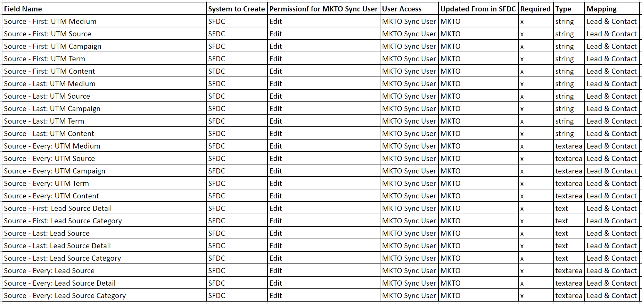
*Considerations: field blocking

Difference Between First, Every and Last
In short, “Last” stands for the most recent values we captured where “First” should show the values that we captured when the person was initially (or first) created in our system. The “Every” fields are used to show all of the values that we have ever captured for a person over time (concatenated).

Fields Used in Program Logic
The “Source - Last: UTM XXXX” fields are the primary fields that are used to make this program function. The “Source - Last: UTM XXXX” fields are captured by adding them as hidden fields to all Marketo forms (or included in a list import). The values you capture in this process are pulled from the query string values (aka parameters) you added to the URL that drove people to your site.

Example
www.etumos.com/?&utm_source=google&utm_medium=textad&utm_campaign=HR_Health_Audit_2020

Once these values exist in the URL, they can be pulled into the hidden fields on your form using one of the following options: a URL Parameter, a Cookie Value or a Referrer Parameter. You can also set a default value for these fields when none exist which is encouraged to understand a form submission that was not driven by marketing/sales efforts. Learn more in Marketo’s product docs on Setting a Hidden Form Field Value.

Now that we have our “Source - Last: UTM XXX” fields filled, our program can manage the remaining fields outlined earlier in this documentation.

Lead Source Flow Diagram
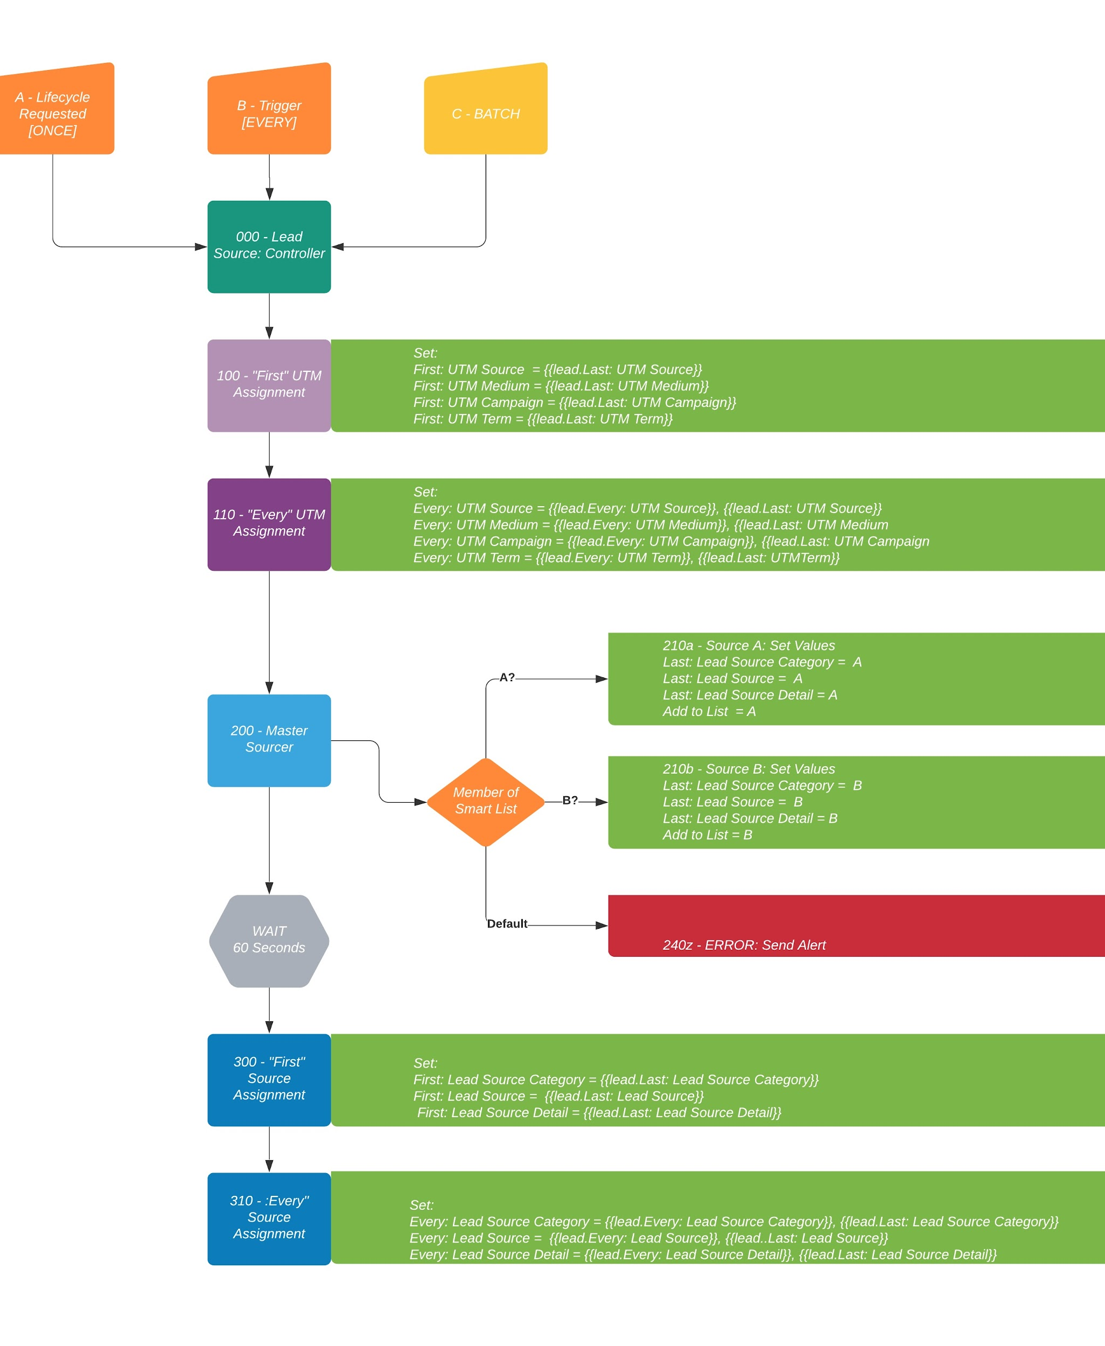
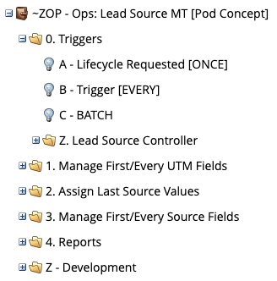

Description - Lead Source Program
Link to Program Template

The program starts in the 0. Triggers with 3 smart campaigns listening for the kick-off to begin managing utm and lead source fields. A - Lifecycle Requested [ONCE] campaign is directly requested from Original Processing in the global Lifecycle Processing program. People will run through this campaign upon creation in the database. B - Trigger [EVERY] is a triggered campaign that runs anytime a new form is submitted. C - BATCH can be used as a one-time batch to run existing records through this program.

All of the initial triggers request the 000 - Lead Source: Controller. This campaign manages all processing by requesting the following campaigns in order shown below.

- 100 - “First” UTM Assignment
- 110 - “Every” UTM Assignment
- 200 - Master Sourcer
- Wait (60 seconds)
- 300 - “First” Source Assignment
- 310 - “Every” Source Assignment

Let’s dig into each of these campaigns to understand what they are actually doing.

100 - “First” UTM Assignment [link]
This is the first campaign that is requested from the 0. Triggers campaigns and appends the “First” UTM values if they are empty for a record. It appends these values using the “Last” UTM values as a Lead/Person token in the campaign flow.
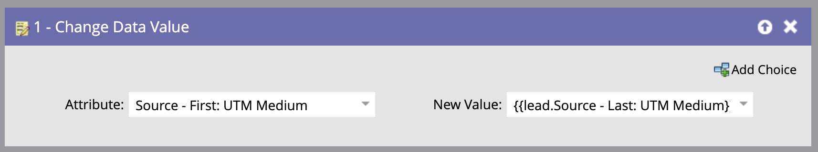
This campaign sets the value for all of the “Last” UTM fields that are being managed in your instance. Qualification rules limit records to only qualify once for this campaign.

110 - “Every” UTM Assignment [link]
This is the second campaign that is requested from the 0. Triggers campaign and appends or concatenates the “Every” UTM values for a record. Like 100 - “First” UTM Assignment, it appends/concatenates these fields using the “Last” UTM values. Unlike 100 - “First” UTM Assignment this campaign uses 1 choice and a default in the flow step for each field. The choice sets the field if empty, and default concatenates the existing “Every” field value with the “Last” value. Qualification rules allow this campaign to run every time.

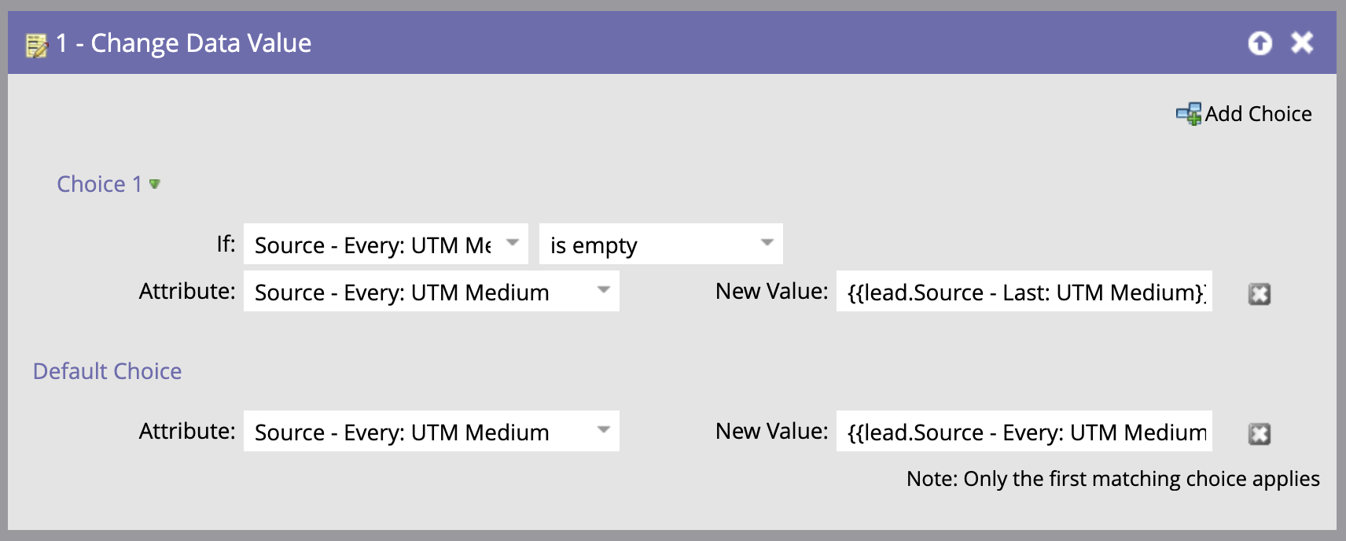

This campaign sets the value for all of the “Every” UTM fields that are being managed in your instance. An example of the default token value used on the image above is shown below.

Source = Every: UTM XXX = {{lead.Source - Every: UTM XXX}} | {{lead.Source - Last: UTM XXX}}

*Note: Use Lead/Person tokens to populate the New Value in the flow. For the default choice, use a pipe ( | ) character to divide what already exists in the Every: UTM XXX field from the Last: UTM XXX field. This can be helpful when parsing the values of every interaction over time. It is recommended to set this standardized value at the launch of the program and keep for the life of the program.

Once this campaign has run, we now have values in the Last, First, and Every UTM fields for a person.

200 - Master Sourcer [link]
The purpose of the 200 - Master Sourcer campaign is to determine what Lead Source, Category and Detail a record should have based on the “Last” UTM values that currently exist. As this campaign is a router, it uses choices to evaluate the person against various smart lists that align Last UTM values to each Lead Source, Category and Detail. When a person meets the criteria of a choice, the router requests the appropriate 2XX series campaign.

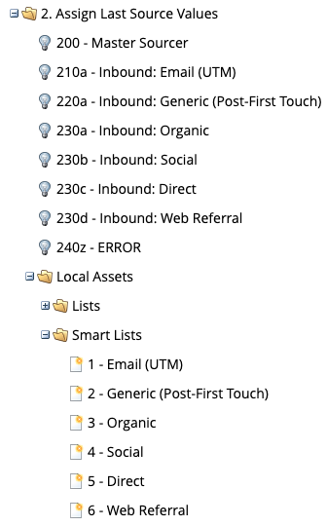
In the image shown to the right, you can see the 2XX campaigns in addition to the 2XX smart lists that are used by the 200 - Master Sourcer to route the record to the appropriate 2XX series campaign.

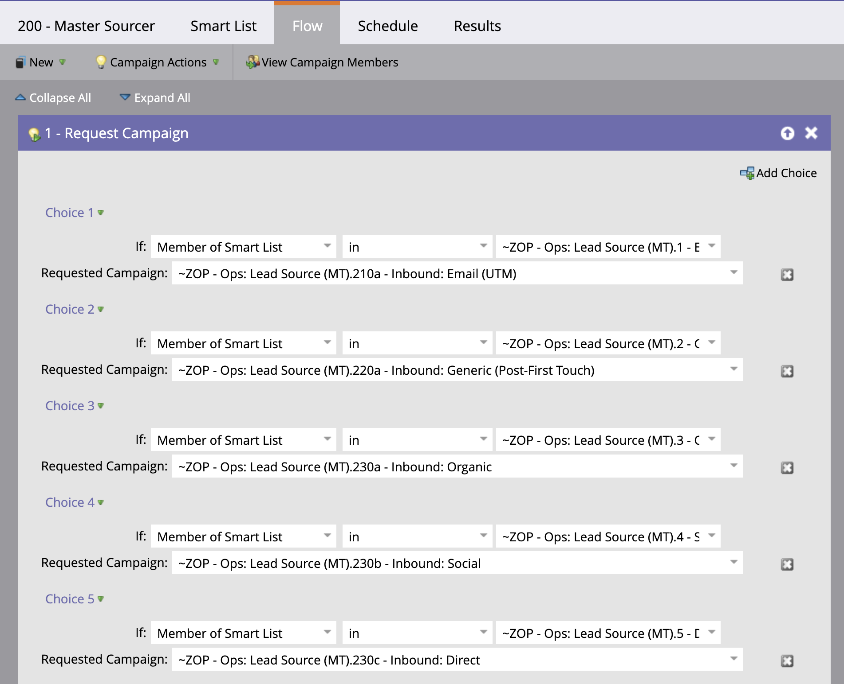

In the image above, you can see how the 200 - Master Sourcer uses the smart lists to request the appropriate 2XX series campaign.
The flow steps of the 2XX series campaigns set the following fields:
- Source - Last: Lead Source Category
  - Typically “Inbound” or “Outbound” value based on choice smart list qualified for
- Source - Last: Lead Source
  - Value will be “Category: Source”. Example, Person matches the smart list choice for 1 - Email (UTM). The value in the campaign flow would be “Inbound: Email (UTM)
- Source - Last: Lead Source Detail
  - The new value for this field concatenates the Source - Last: Lead Source value, the Source - Last: UTM Source value, and the Source - Last: UTM Campaign value to deliver specific details of which initiative a person converted from. The value used in the flow step following our previous example would be “Inbound: Email (UTM) - {{lead.Source - Last: UTM Source}} {{lead.Source - Last: UTM Campaign}}

Qualification rules allow records to run through this campaign every time.
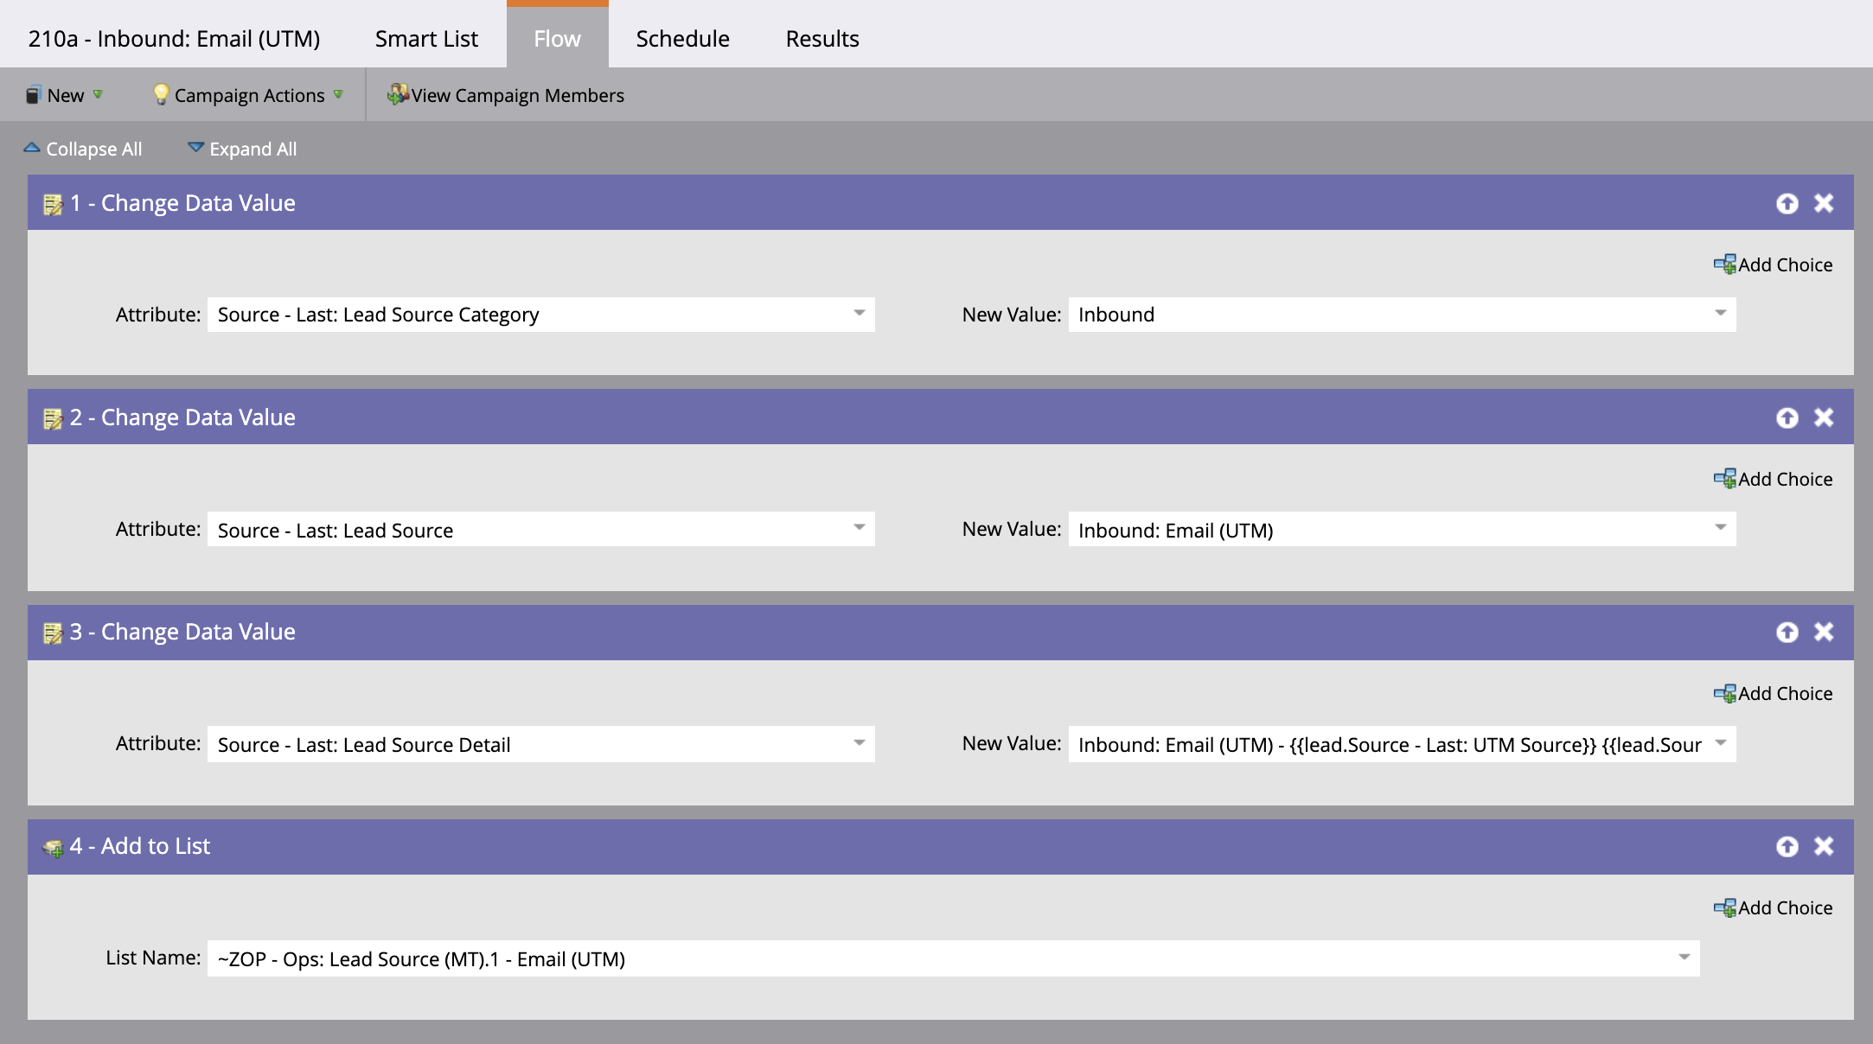

Wait 60 Seconds
While the process above if happening, the primary 0. Triggers campaign is in a 60 second wait to ensure the ”Last” source values are set before requesting 300 - “First” Source Assignment and then 310 - “Every” Source Assignment. This is important as both 300 - “First” Source Assignment and 310 - “Every” Source Assignment use the “Last” source fields in their flows.

300 - “First” Source Assignment [link]
This campaign appends the “First” Source, Category and Details fields IF they are empty using the “Last” Source values that were set in the 2XX campaigns. Qualification rules limit records to only qualify once for this campaign.

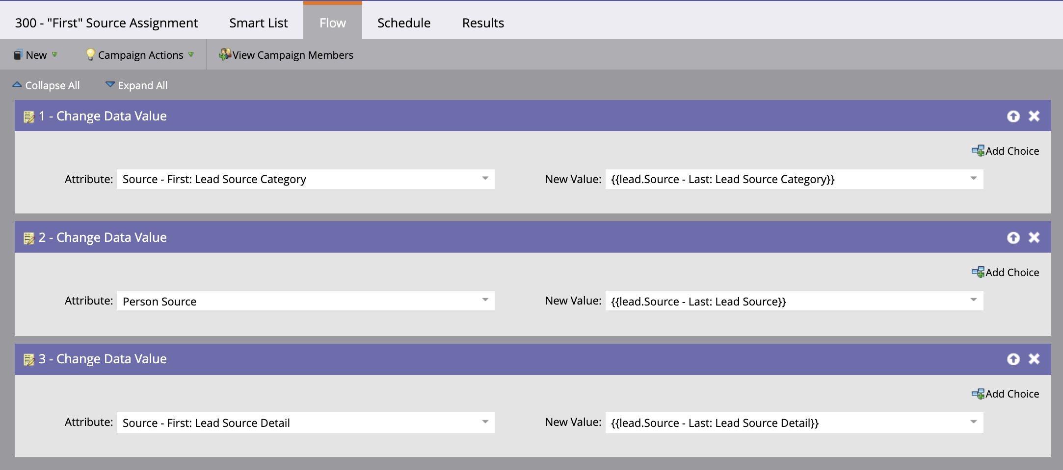

310 - “Every” Source Assignment [link]
This campaign appends or concatenates the “Every” Source fields for a record. Like 300 - “First” Source Assignment, it appends/concatenates these fields using the “Last” Source values. Unlike 300 - “First” Source Assignment this campaign uses 1 choice and a default in the flow step for each field. The choice sets the fields if empty, and default concatenates the existing “Every” field with the “Last” value. Qualification rules allow records to run through this campaign every time.

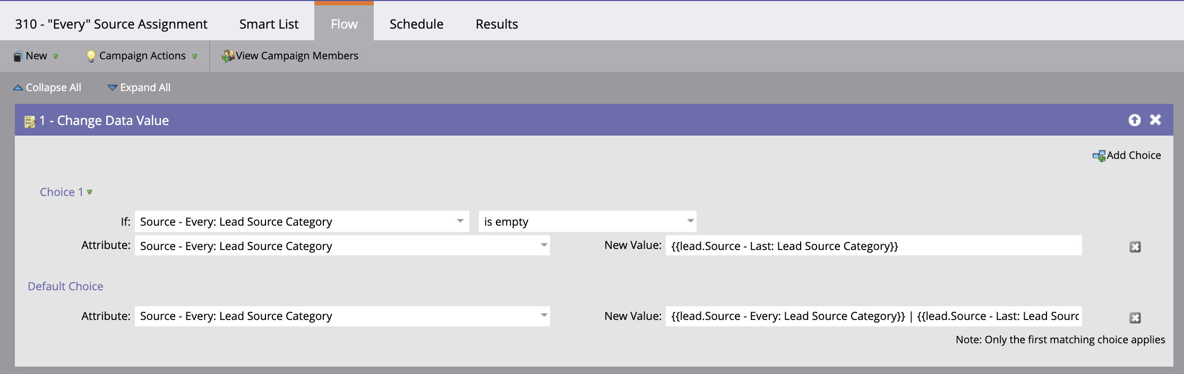

Conclusion
Now that this program has finished running we now have data appended for all fields shown in the fields managed by program image.

Where these fields are managed and appended by the program is shown in the matrix below.
 | Last | First | Every
UTM XXXX | Form Submit  or Import | 100 - “First” UTM  = Last: UTM XXXX | 110 - “Every” UTM  = Every + Last: UTM XXXX
Lead Source | 210x - [Source] | 300 - “First” Source  = Last: Source XXXX | 310 - “Every” Source  = Every + Last: Source XXXX

Now that we have captured all these values on the lead or contact, we understand where and why a person was created in our system. This data is also useful in understanding channels that drive the most leads, channels that drive the highest qualified leads.

There is value in passing these values to any opportunities created from the lead or contact to understand the source of the opportunity. As a result, we typically recommend that you create the “First” and “Last” fields managed by this program on your opportunity object. When an opportunity is created, these values should be appended using the values that exist on the lead/contact. This will give you insight into the source of your opportunities.

